Project Design Phase-II Technology Stack (Architecture & Stack)

Date | 15 July 2026
Team ID | SWTID-2026-3267
Project Name | Stock Trading App
Maximum Marks | 4 Marks

Technical Architecture:
The deliverable includes the architectural diagram below along with the information captured in Table 1 and Table 2.

Stock Trading App – Paper Trading Simulation Platform
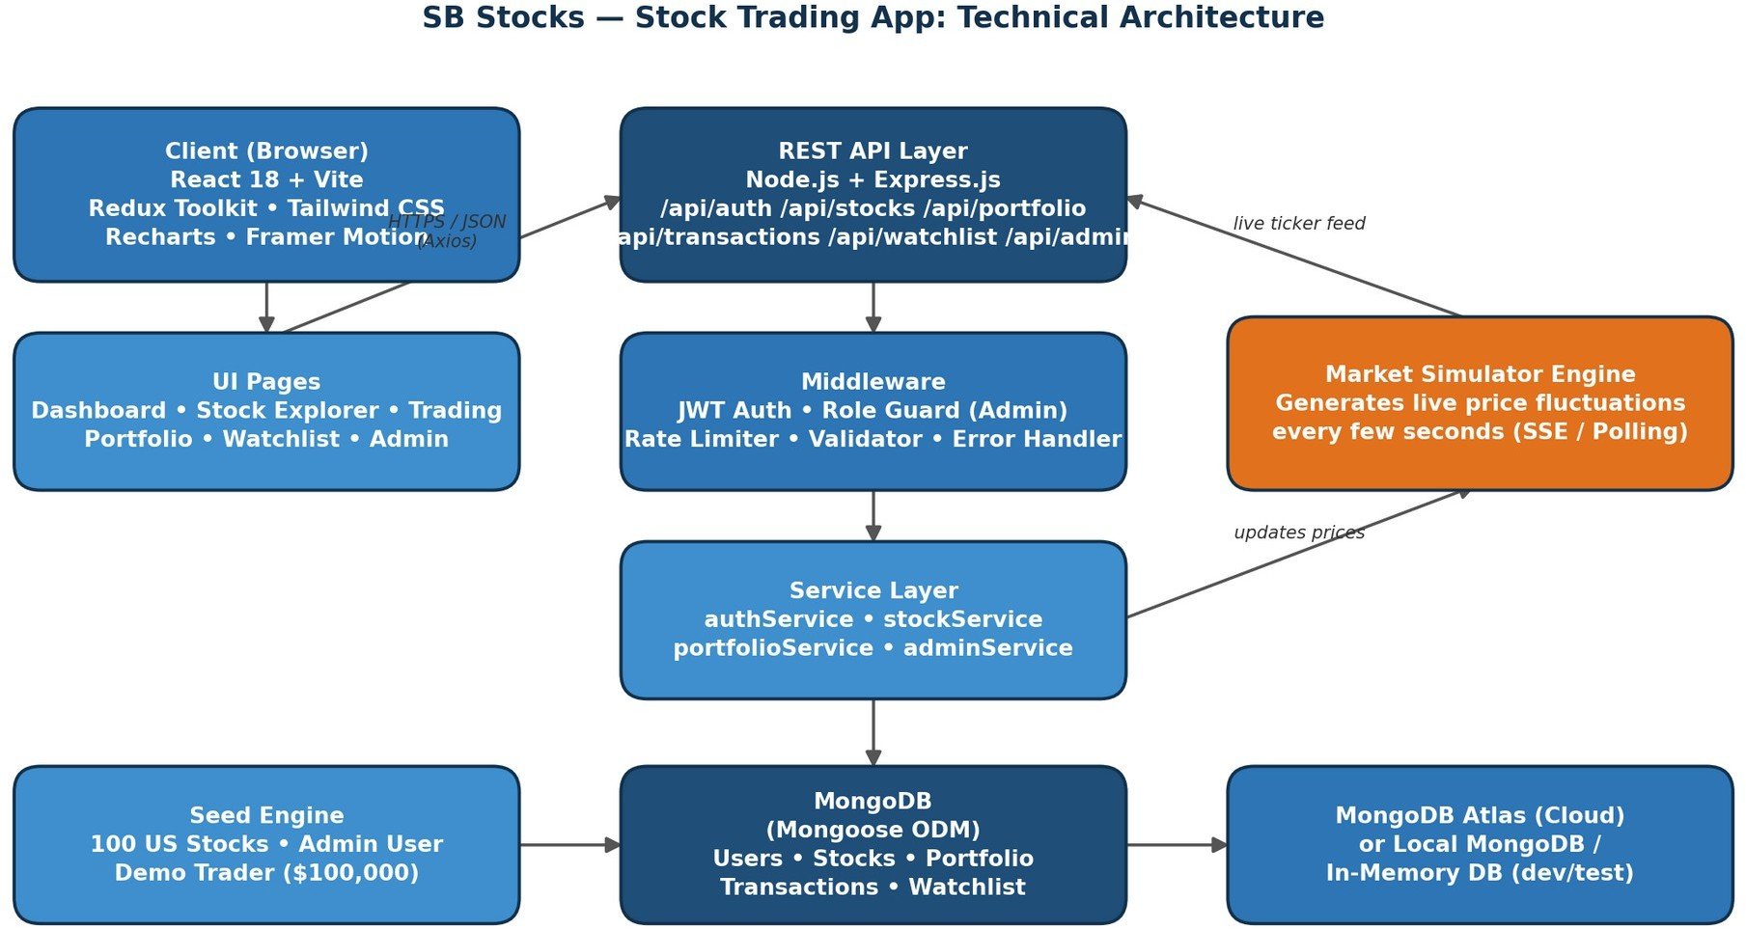

Table-1 : Components & Technologies:

S.No | Component | Description | Technology
1 | User Interface | Web application UI for browsing stocks, executing trades, and tracking portfolios | React 18, Vite, Redux Toolkit, Tailwind CSS, Lucide Icons, Recharts, Framer Motion
2 | Application Logic-1 (Authentication &  Security) | User registration, login, JWT session handling, role-based access  (User/Admin) | Node.js, Express.js, JWT, bcrypt
3 | Application Logic-2 (Trading & Portfolio Engine) | Executes BUY/SELL orders, updates holdings, calculates average price and P&L | Node.js, Express.js REST APIs, Mongoose
4 | Application Logic-3 (Market Simulator Engine) | Simulates dynamic live price fluctuations for 100 US stocks at set intervals | Node.js scheduled service, SSE / Polling
5 | Database | Stores users, stocks, portfolios,  transactions and watchlists | MongoDB, Mongoose ODM
6 | Cloud Database | Cloud-hosted database for persistent storage | MongoDB Atlas
7 | File Storage | Local server storage for logs and | Local Filesystem

S.No | Component | Description | Technology
 |  | static/demo assets
8 | External API-1 | Not applicable – live price feed is generated internally by the Market Simulator Engine | N/A
9 | External API-2 | Not applicable – no third-party market data provider is used in this simulation | N/A
10 | Machine Learning Model | Not applicable to the current scope of  this project | N/A
11 | Infrastructure (Server / Cloud) | Application deployment on local system or cloud Local Server Configuration: Node.js + local MongoDB / mongodb-memory-server Cloud Server Configuration: Node.js hosting (e.g. Render/Railway) + MongoDB Atlas + static hosting for client build | Local, Render/Railway, MongoDB Atlas

Table-2: Application Characteristics:

S.No | Characteristics | Description | Technology
1 | Open-Source Frameworks | Open-source frameworks and libraries used to build the client and server | React, Redux Toolkit, Express.js, Mongoose, Tailwind CSS, Recharts
2 | Security Implementations | Security and access controls implemented across the platform | bcrypt password hashing, JWT authentication, role-based access control, rate limiting, input  validation middleware
3 | Scalable Architecture | Justifies the scalability of the architecture used | 3-tier architecture (Client – Server – Database) with a modular service layer, stateless REST APIs
4 | Availability | Justifies the availability of the application | Stateless Node.js/Express services allow horizontal scaling; MongoDB Atlas replica sets for data availability
5 | Performance | Design considerations for application performance | Indexed MongoDB queries, pagination, client-side caching, code-splitting via Vite, lightweight polling/SSE for live prices

